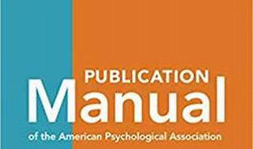

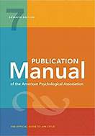

Explore

**Apache Commons** is an **Apache project** focused on all aspects of **reusable Java components**. [It comprises three main parts: **Commons Proper** (a repository of reusable Java components), **Commons Sandbox** (a workspace for Java component development), and **Commons Dormant** (a repository of currently inactive components)](https://commons.apache.org/) [1](https://commons.apache.org/).

Here are **five free reference links** where you can learn more about Apache Commons:

1. [**Apache Commons Official Website**](https://commons.apache.org/): Explore the official documentation, project details, and various components within Apache Commons [1](https://commons.apache.org/).
2. [**Baeldung’s Introduction to Apache Commons Lang 3**](https://www.baeldung.com/java-commons-lang-3): Dive into the popular Apache Commons Lang 3 library, which provides utility classes for extending Java functionality [2](https://www.baeldung.com/java-commons-lang-3).
3. [**Java Code Examples - Apache Commons Tutorial**](https://www.javacodeexamples.com/apache-commons-tutorial-with-examples/1588): Learn how to use Apache Commons classes effectively with practical examples [3](https://www.javacodeexamples.com/apache-commons-tutorial-with-examples/1588).
4. [**MyBib’s Free APA Citation Generator**](https://www.mybib.com/tools/apa-citation-generator): While not directly related to Apache Commons, this tool helps you generate APA-style citations for your academic work [4](https://www.mybib.com/tools/apa-citation-generator).
5. [**Scribbr’s APA Citation Generator**](https://www.scribbr.com/citation/generator/apa/): Another handy citation generator specifically tailored for APA style [5](https://www.scribbr.com/citation/generator/apa/).

Feel free to explore these resources to enhance your understanding of Apache Commons! 🚀